Chapter 6. Lotus Notes
E-Mail Integration

Table of Contents
1. Introduction and Concepts 3
2. References 3
3. Registering E-mail and Attachments 3
1. << Correction >> 4
4. Logging on RAMP-TRIM 6
5. Cataloging the E-Mail Message 7
2. << Correction >> 8
5.1 Record Item Title [Required Field] 8
5.2 Author 8
5.3 In, Out, Internal (Fd1) 9
5.4 Date Created 9
5.5 ExRef: Document Series/Year/Number 9
5.6 Date Due 9
5.7 Action 9
5.8 Notes 9
5.9 Priority 9
5.10 DOC File Name 9
5.11 Fg2: Current 10
5.12 Fg1: Status Certain? 10
5.13 Owner Location 10
5.14 Current Location 10
6. Containers/Local Folders 10
7. Printing Item Tracking Reports 11
8. Key Learning points 12
3. << Correction >> 12

List of Figures

Figure 1. Lotus Notes Today 4
Figure 2 Lotus Notes Inbox for E-mail 5
Figure 3. RAMP-TRIM Login Window 6
Figure 4. RAMP-TRIM Record Type Selection Window 6
Figure 5. Catalog Attachment Query Message 7
Figure 6. Correspondence or other Item Registration Entry Form 8
Figure 7. Container Menu [used for local folders when registering items] 11
Figure 8. Container/Local Folder Entry Form 11

Introduction and Concepts
Lotus Notes is the organizations’ official E-mail system that integrates with RAMP-TRIM in order to manage and track electronic objects. This procedure covers registering a new E-mail correspondence item and/or electronic attachment into the RAMP-TRIM application. Concepts and procedures described in Correspondence and Item Tracking, Section 5.0 may also be applied to E-mail correspondence. Consult with Section 5.0 for information on creating relationships, saved searches, assigning or completing or modifying a tracking task [e.g., workflow tasks.]

References
The RAMP-TRIM manual chapters 1 through 3 describe basic navigation procedures, records searching, and management of series records. Review these documents before beginning E-mail Correspondence Tracking concepts.

The following terms are used in this document and the definitions are provided here for reference purposes.

Action A single step in a correspondence process
Process Two or more steps required completing the correspondence-tracking task
KwikSelect The yellow folder icon placed to the right of a field and used to access an authority
Record View Pane The portion of the search result displayed under the record list.
TopDrawer TopDrawer is a desktop application used to manage electronic files and catalog those records in the RAMP-TRIM application.
Workflow A process consisting of a number of Actions. Each of the actions must be completed for the record to have been successfully processed.

Registering E-mail and Attachments
Open the Lotus Notes E-mail application and you will see on the menu bar with three RAMP-TRIM icons. These icons allow you to catalog an E-mail message or an attachment using RAMP-TRIM or TopDrawer.

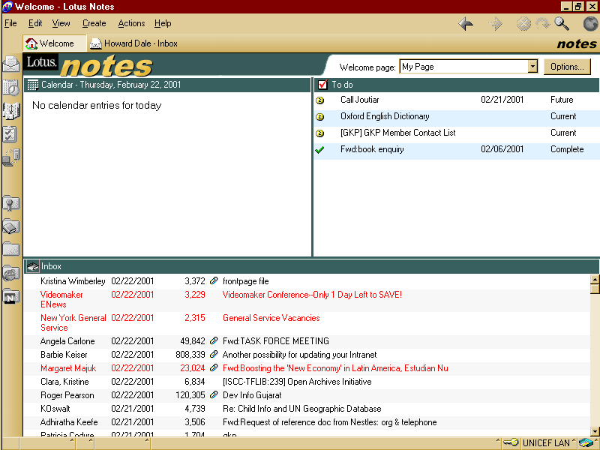

Figure 1. Lotus Notes Today

<< Correction >>

I don’t see the TRIM icons on the Lotus Notes Desktop. Are they installed?
<<Close Correction >>

From left to right the first icon (appear in the upper right corner of the screen) is used to catalog a message and it’s attachment in RAMP-TRIM. The middle icon catalogs only the attachment to TopDrawer – a desktop document management interface with RAMP-TRIM. The right icon opens TopDrawer. Now, highlight the desired Lotus Mail record and move the cursor over the icon to display a detailed title.

Figure 2 Lotus Notes Inbox for E-mail

Select the desired icon to log the E-mail and/or attachment into RAMP-TRIM.

Logging on RAMP-TRIM
Select the catalog message icon will ask you to login to RAMP-TRIP with message window shown below. In this window enter your RAMP-TRIM user name and your password. The Database name will default to RAMP-TRIM and you will not change the database name in most circumstances.

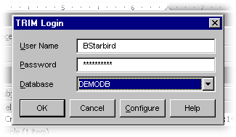
Figure 3. RAMP-TRIM Login Window

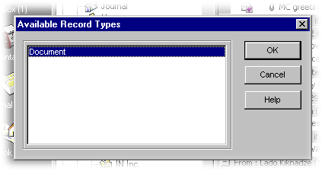
Figure 4. RAMP-TRIM Record Type Selection Window

After Logging on, a list of the available electronic Record Types is presented. Highlight the Correspondence Tracking entry and select OK. You are asking to include the attachments or disregard them. This query window is show below in Figure 5.

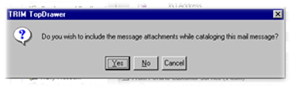
Figure 5. Catalog Attachment Query Message

Choose yes to include the attachments, or No to catalog only the message. RAMP-TRIM will present the Correspondence tracking form for your data entry.

Cataloging the E-Mail Message

Registration of a new E-mail begins with the Correspondence Item form. Fill in the fields
presented on the form using the following descriptions as your guide.

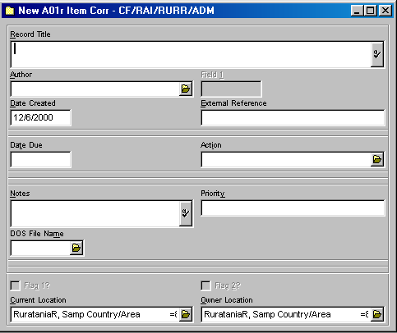

Figure 6. Correspondence or other Item Registration Entry Form

<< Correction >>

This figure should be replaced with the current Form. This was taken from a previous version of RAMP – TRIM. <<Close Correction>>

Record Item Title [Required Field]
Enter a text title of your choice up to 256 alphanumeric characters in length.

Author
Select an authorized author using the yellow KwikSelect folder to display an alphabetical author list. Optionally, on display of the alphabetical list, select the Search button, assure the Contact box is checked, enter the author’s last name in the field titled Prefix, and select Do Search to display a list of author sorted by last name. As in the previous search, highlight the correct name and select OK.

In, Out, Internal (Fd1)
The field titled Internal, In, Out signifies the record is for use internal to the work unit (division or section), internal to UNICEF, or external circulation, respectively. Consider preparing a guideline document for reference purposes in your work area.

Date Created
The Date Created field is automatically populated with today’s date. You will enter the date the record was created [the date created may not be the RAMP-TRIM registration date]; however you must enter the full year, e.g. 12/May/2000. This will usually be the date on an incoming correspondence

ExRef: Document Series/Year/Number
Enter information, provided by another information system that has lasting value to managing the correspondence. For example, previously used document numbers from another work unit might be recorded. The field is limited to no more than 50 alphanumeric characters, e.g. CF/EXD/1997-001 or E/ICEF/1998-003.

Date Due
Enter a date on which all tracking actions must be completed. The Date Due is for reference and not used for calculation purposes.

Action
Open the yellow KwikSelect folder to view all available correspondence tracking actions. Scan the list and highlight the desired task or the desired correspondence tracking process

Notes
Enter information that describes the records and that has long-term value in the context of this record. You can enter up to about 30,000 characters or 32Kb in to this field. The field cannot be formatted like a word processing record though it is quite large in size.

Priority
Enter a priority text statement or code that is no more than 5 characters in length. Priority information is for use by staff members in your office. It might be useful to create a standard priority code reference sheet to assure codes are applied in the same manner over time, and that unnecessary or similar codes are not created.

DOC File Name
Leave this field blank if: 1) you are working with hardcopy [paper] records, or 2) you have catalogued the record through RAMP-TRIM TopDrawer.

Use this field if the document is an electronic record and located on a server outside of RAMP-TRIM. Use the KwikSelect and navigate the path to the correspondence document.

Fg2: Current
Enter a checkmark if the document status is current. If not, leave the check box blank.

Fg1: Status Certain?
Enter a checkmark if you are certain of the document status. If you are not certain of the status leave the check box blank.

Owner Location
The organization, unit or individual responsible for the correspondence item. The field value will default to the division, unit or organization.

Current Location
The organization, unit or individual currently holding correspondence item.

Note that most fields are not required, however the greater a level of description may make it easier to locate documents at a later time.

Containers/Local Folders
E-Mail should be placed in a RAMP-TRIM folder – also called a container in - for retrieval purposes. Folders help to manage all kinds of records, whether they are correspondence, reports, working papers, or etc. This is because these records can be located under a primary heading.

Unlike traditional paper folders, RAMP-TRIM folders can manage records created in different media. For example, a Water Resources Folder might contain E-mail or hardcopy correspondence created within Unique on word processing systems, correspondence received via facsimile and paper, resource analysis in hardcopy with notes, research data in a database format. Basically RAMP-TRIM folders may manage any record media [e.g., paper, electronic, CD, microfilm, etc.]

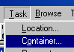

Figure 7. Container Menu [used for local folders when registering items]

To illustrate, create a folder and the correspondence item. Display the correspondence item through a search and navigate the menu path from Task to Container and the Container form is presented. Enter the folder number, or search for the container number, check the Enclose Record Now radio button and Ok. The correspondence is now contained –
Virtually contained this is – within the folders.

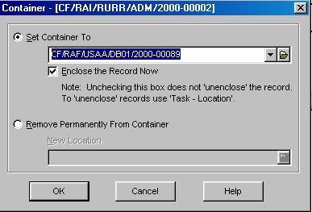

Figure 8. Container/Local Folder Entry Form

You can identify the related container in one of two ways. Display the field Container Record number in the lower Record View Pane; or, from the upper Record List Pane with the record highlighted, right click the mouse, and select Navigate and Contained Records . Navigate and Contained Records can also be accessed through the main menu.
Once the folder is displayed, you can also choose Navigate and Container Records to see a complete list of records within the folder.

Printing Item Tracking Reports
E-mail records can be printed through the standard report option in RAMP-TRIM. When printing, review the report layout list to determine which report format best suits your requirements and print the report.

Access to Standard Reports Navigate the menu path File and Print Report.

Key Learning points

You will learn a method by which to catalog E-mail messages into RAMP-TRIM.

You will learn a method by which you can catalog E-mail attachments into RAMP-TRIM.

<< Correction >>

Are there additional learning points that you would like listed?

As usual I’ll be glad to add any new language or make changes that will clarify the text to students. Please markup as necessary to tailor the text for the trainers.

<< Close correction>>

A process contains more than one action that must be competed. In contrast the task is a singular event that must occur to complete the tracking action.
A new relationship can be created thought this screen simply by selecting New.

